Bug report №56

|  |  |
| --- | --- |
| Tittle | App Ex.me won't open on restart |
| Priority | High |
| Environmental | Xiaomi Redmi Note 6 Pro, Android 7.0 |

**Steps to reproduce :**

1.Open app “Ex.me” on mobile device.

2. Close the application

3. Start the application again

**Actual result :**

The app won't open until you clear the cache.

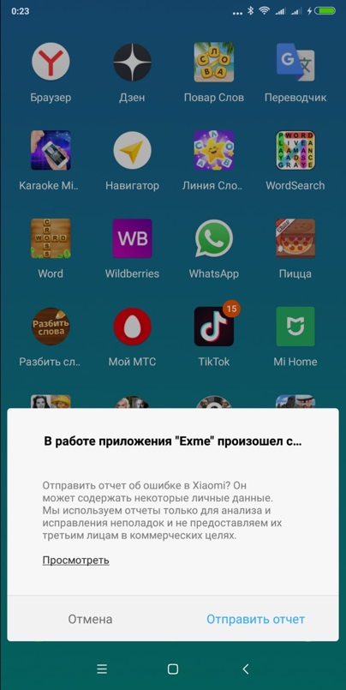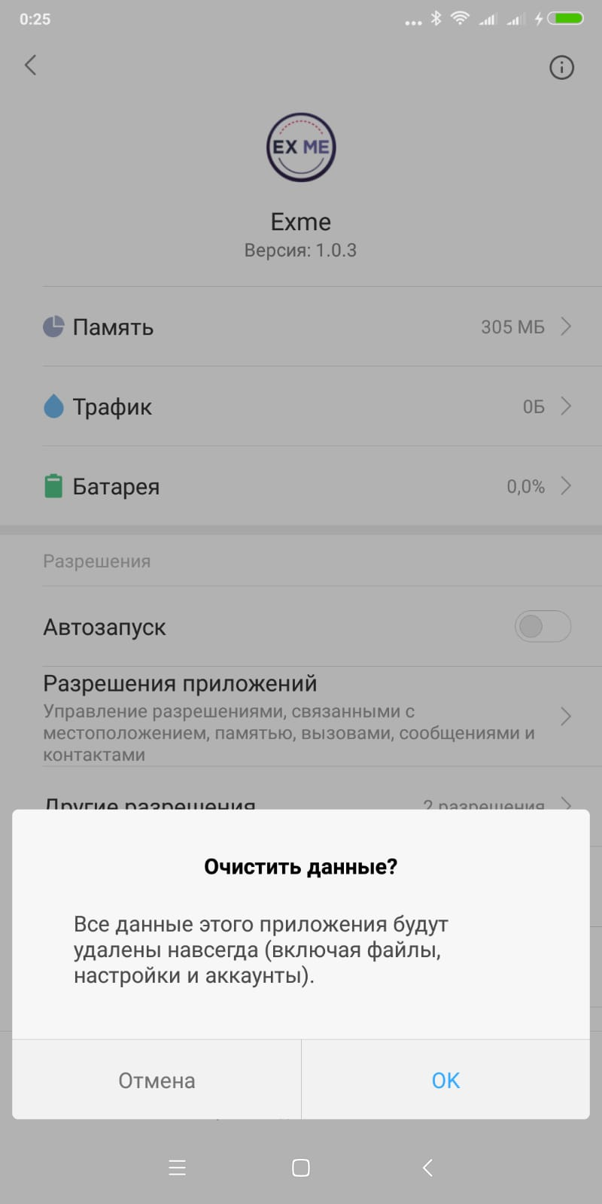

**Log**: 2022-01-06 23:59:31.416 16656-16721/? E/AndroidRuntime: FATAL EXCEPTION: mqt_native_modules

Process: com.psygamesdev.exme, PID: 16656

com.facebook.react.common.JavascriptException: TypeError: undefined is not an object (evaluating 'o.default.getRegistrationInfoAsync'), stack:

<unknown>@1140:1764

v@2:1473

<unknown>@1137:3811

v@2:1473

<unknown>@1134:3955

v@2:1473

<unknown>@1117:1376

v@2:1473

<unknown>@1111:384

v@2:1473

<unknown>@560:1833

v@2:1473

<unknown>@6:69

v@2:1473

d@2:875

global code@1368:3

at com.facebook.react.modules.core.ExceptionsManagerModule.reportException(ExceptionsManagerModule.java:83)

at java.lang.reflect.Method.invoke(Native Method)

at com.facebook.react.bridge.JavaMethodWrapper.invoke(JavaMethodWrapper.java:372)

at com.facebook.react.bridge.JavaModuleWrapper.invoke(JavaModuleWrapper.java:151)

at com.facebook.react.bridge.queue.NativeRunnable.run(Native Method)

at android.os.Handler.handleCallback(Handler.java:754)

at android.os.Handler.dispatchMessage(Handler.java:95)

at com.facebook.react.bridge.queue.MessageQueueThreadHandler.dispatchMessage(MessageQueueThreadHandler.java:27)

at android.os.Looper.loop(Looper.java:163)

at com.facebook.react.bridge.queue.MessageQueueThreadImpl$4.run(MessageQueueThreadImpl.java:226)

at java.lang.Thread.run(Thread.java:760)

**Expected result**: application started